Assignment # 4 and 5. (10 marks)
Write an HTML/CSS code to produce a content similar to the following image:
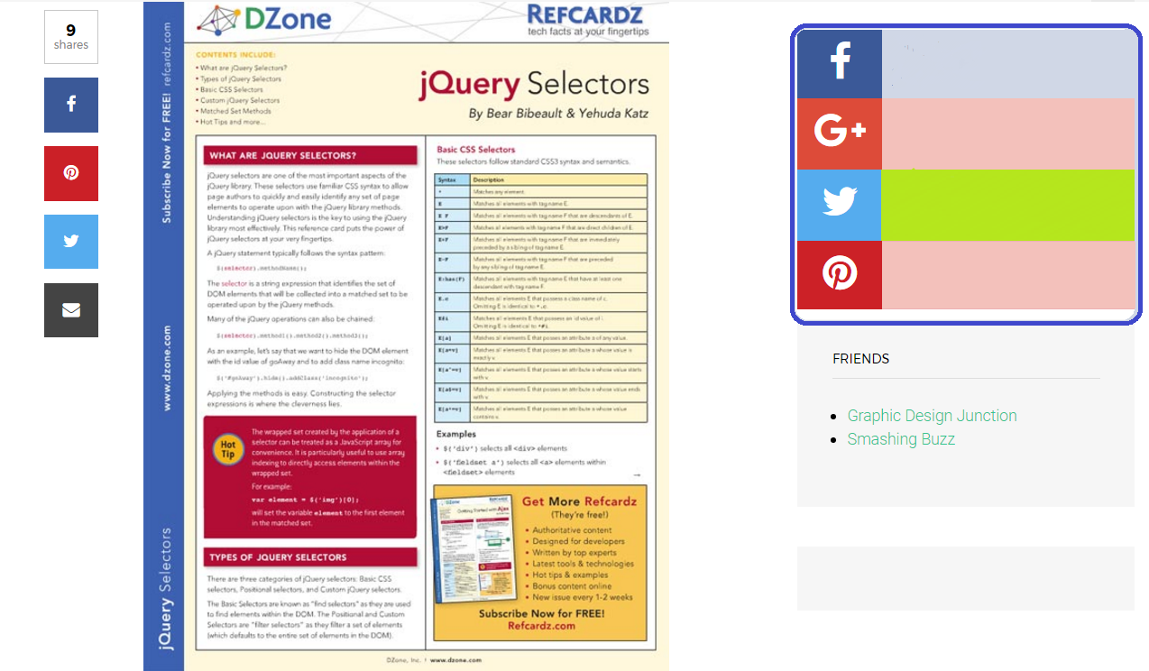
- Number 1
- Number 2
  - Sub22
  - Sub22
- Number 3
2.

Submit an HTML file that has the CSS style code within ( submit only one file). Do not zip please.

